Project Design Phase-II
Data Flow Diagram & User Stories

Date | 08-12-2025
Team ID
Project Name | Book Doctor
Maximum Marks | 4 Marks

Data Flow Diagrams:
A Data Flow Diagram (DFD) illustrates how data moves within the DocSpot platform. It captures how users (User and Doctor) interact with the system, how information flows between different components, and where the data is stored.

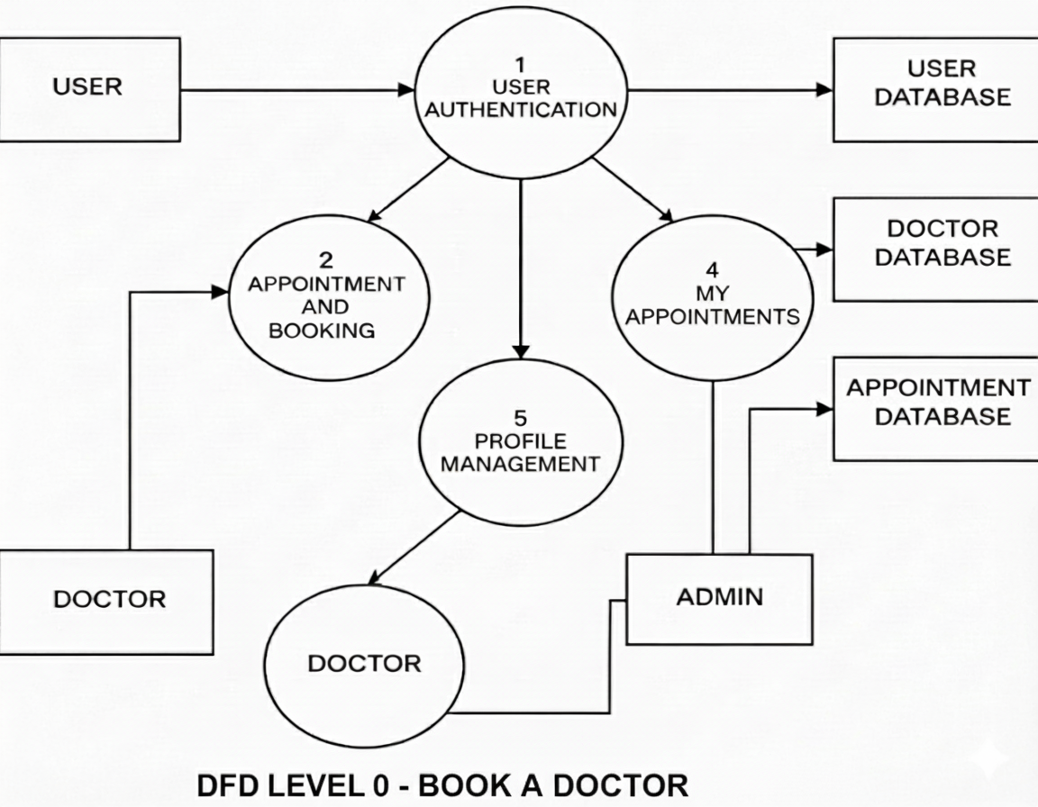

User Stories
User Story Table – Freelance Finder

User Type | Functional Requirement (Epic) | User Story / Task | Acceptance Criteria | Priority | Release
user | Appointment Booking | As a user, I can search for a doctor based on specialty, location, or availability. | Search results show relevant doctors with available time slots. | high | Sprint-1
User | Appointment Booking | As a user, I can book an available appointment slot with a doctor | A confirmation is received, and the appointment appears in my 'My Appointments' section. | Medium | Sprint -2
Doctor | Appointment Management | As a doctor, I can view and manage my schedule and accepted appointments. | Filter allows viewing appointments by date, status, or user. | High | Sprint-1
User | Appointment Management | As a user, I can cancel or reschedule an existing appointment. | Cancellation/rescheduling is confirmed, and the doctor is notified. | Medium | Sprint-2
Doctor | Profile Management | As a doctor, I can update my profile details, including specialty, availability, and consultation fees. | Changes are immediately reflected in search results for users. | High | Sprint-2
Admin | User Moderation | As an admin, I can view and manage reported doctor/user profiles and take appropriate action. | All reports and actions are logged and accessible in the admin dashboard. | High | Sprint-1

